Application Migration Assessment Discovery and Design

Table of Contents

1 Overview 1

2 Application Profile 1

3 Methodology 1

4 Architecture and Platform (Current & Future) 1

4.1 Current Architecture 1

4.2 Findings and Risks 1

4.3 Recommendations 1

5 Infrastructure 1

5.1 Findings and Risks 1

5.2 Recommendations 1

6 Security and Compliance(TBD) 1

6.1 Findings and Risks(TBD) 1

6.2 Recommendations(TBD) 1

7 Data Management(TBD) 1

7.1 Data classification and tagging(TBD) 1

7.2 Findings and Risks(TBD) 1

7.3 Recommendations(TBD) 1

8 TCO Assessment & Management(TBD) 1

8.1 Findings and Risks 1

8.2 Recommendations 1

9 Business Continuity & Disaster Recovery(TBD) 1

9.1 Findings and Risks(TBD) 2

9.2 Recommendations 2

10 Annexure 1: Server List 2

# Overview

* **Highland OnBase System**: Document management system integrated with Epic.
* **Migration to Azure: Lift and Shift**
* **Current Hosting**: OnBase hosted on-premises by Optum.
* **Migration Plan**:
  + West region moving to Azure in Q3.
  + East region moving to Azure in Q4.
* **Coordination with Epic Migration**: Ensuring synchronization between OnBase and Epic migrations to avoid latency issues.
* The application is currently hosted in both **ELR & CTC datacenters for production and nonproduction.**
* **Database size: 1 TB (East and West)**
* **Process Flow**: OnBase loads information into its database and sends metadata to Epic as flat files.
* **Interface**: Converts flat files to HL7 format for Epic integration.
* **Image Viewing**: Images stored in OnBase, accessible via Epic
* **Recovery Point Objective (RPO) and Recovery Time Objective (RTO)**: acceptable data loss and recovery times (8 to 12 hours).
* **Data Storage and Recovery**: Ensure no data loss with NAS drives and proper recovery mechanisms.
* **Hyland East Environment** (App, Web, DB): 7 TEST VMs, 11 PROD VMs, 8 DR VMs – details in Infra sheet
* **Hyland West Environment** (App, Web, DB): 7 TEST VMs, 12 Stage, 12 PROD VMs, 8 DR VMs – details in Infra sheet
* OnBase's administration tools are used
* **Database**: MS SQL Server 2019/2022
* Current: App Server and Web servers
* Current: **Load balancer is F5**, F5 - Cookie-based (Layer 7) as “Client affinity” or “sticky” sessions
* **Languages used: .NET and C#**
* **Authentication** MS AD; Administrator ID and AD
* **Disaster Recovery**: utilizing a clustered database setup with Node 1 located in the AZA data center and Node 2 situated in the DR data center in Cheska.
* **Target**: Azure Premium Disk for Data Base and OnBase Disk groups
* Performance Metrics
  + Server Performance: Monitor CPU usage, memory usage, IIS, and disk I/O to ensure servers are performing optimally.
  + Database Health: Regularly check database performance metrics such as query response times and transaction rates.
  + Security Activity: Track user activity to identify and address any irregular or suspicious behavior
* Hyland OnBase applications can scale horizontally. This means they can handle increased load by adding more instances of the application, rather than just increasing the capacity of existing instances. Horizontal scalability is beneficial for managing large document repositories and accommodating growing numbers of users.
* Hyland OnBase Scalability
  + - Horizontal and Vertical Scalability: OnBase supports both horizontal and vertical growth, making it suitable for large enterprises.
    - Flexible Deployment: The platform allows for flexible deployment options, ensuring it can meet the needs of various industries and organizational sizes.
    - Enhanced Performance: With its ability to scale horizontally, OnBase can maintain high performance levels even as demand increases.

**Technical Considerations**:

* Migrate to Azure Cloud
* **Load Balancing**: Use Azure Application Gateway for load balancing.
* **Server Setup**: New servers in Azure with fresh installations rather than migrating existing servers.
* **Data Migration**: Exporting and importing data from on-premises to Azure.
* **Testing**: Importance of testing in non-production environments before moving to production.
* **Joint Effort**: Collaboration between teams for smooth migration and integration.

**Application tech stack**

* **Client Layer (Front-End):** OnBase Unity Client, OnBase Web Client, OnBase Mobile App built on Windows Forms, .NET Framework, HTML5, JavaScript, IIS,iOS (Swift), Android (Kotlin/Java).
* **Application Layer (OnBase Core Services):** OnBase Web Server, OnBase Application Server, OnBase API Services, OnBase Workflow Engine, OnBase Reporting Dashboards built on IIS (Internet Information Services), ASP.NET, C# .NET, Windows Services, REST, SOAP, WCF, .NET, SQL Server, Power BI, SSRS (SQL Server Reporting Services).
* **Database Layer:** Microsoft SQL Server 2019/2022
* **Document & File Storage Layer**: Windows File Share, SMB, NFS.

**Containerization**: Not included in this phase. The team will investigate containerization in the future.

**Current Infrastructure:**

**Servers:**

**Web Servers**: Two web servers in each data center (production and Cisco).

**App Servers:** Combined web and app servers in production and Cisco data centers.

**Database Servers:** Replicated database setup across production and Cisco data centers.

**Other Servers:** Full test servers, proxy servers, EDP servers, and mirror servers for load balancing and failover.

**Load Balancing:** F5 Load Balancer: Used for sticky sessions and SSL acceleration.

**Active-Active Configuratio**n: Ensures high availability and failover

**Vendor and Support:**

* **Third-Party Vendors**: Coordination with vendors for support during migration.
* **Hyland OnBase Support**: Engage with Hyland OnBase for specific requirements and configurations

# Application Profile

**Hyland OnBase** follows a structured methodology to ensure successful implementation, optimization, and migration across different environments (on-premises, cloud, or hybrid). This methodology includes discovery, design, deployment, and ongoing support, aligned with enterprise content management (ECM) best practices.

Enterprise Content Management (**ECM**) is essential for organizing, storing, and managing digital content efficiently. Proper ECM implementation ensures compliance, security, automation, and seamless integration across an organization. Below are industry best practices for deploying and optimizing ECM systems like Hyland OnBase, OpenText, SharePoint, and IBM FileNet.

OnBase is a **modular platform** consisting of the following key components:

* **Document Repository**: Secure centralized storage for documents, images, and records.
* **Workflow Engine**: Automates business processes using rules-based routing and task management.
* **Capture & Scanning**: Supports OCR (Optical Character Recognition), ICR (Intelligent Character Recognition), and barcode recognition.
* **Integration Services**: Connects with third-party applications like SAP, Salesforce, Epic (for healthcare), and Microsoft 365.

**Points of contact**: Cruz, Roberto; Vu, Samuel; Chisley, Terry;

**LOB**: OHFT - Optum Care Delivery Technology

**App R Disposition:** Re-Host

**OnBase Support Team**

OnBase West Team - LOB Optum SQL Server - [LOBOptumSQLServer_DL@ds.uhc.com](mailto:LOBOptumSQLServer_DL@ds.uhc.com)

OnBase East Team - ORX IT SQL Server DBA - [dl-mssqldba7696@uhgazure.onmicrosoft.com](mailto:dl-mssqldba7696@uhgazure.onmicrosoft.com)

# Methodology

The following methods were used as part of this assessment.

**Discovery sessions:**

Discovery sessions were held using Microsoft Teams Meeting and Chat to review existing documentation for the Hyland OnBase solution  Items reviewed during Discovery are as follows:

1. Current State Architecture
2. Sizing of Servers
3. Backup Requirement
4. Disaster recovery and BCP requirements
5. Application requirements
6. Database Migration Requirements
7. Security & compliance requirement
8. Monitoring and Observability
9. Cost Management

# Architecture and Platform (Current & Future)

## Current Architecture

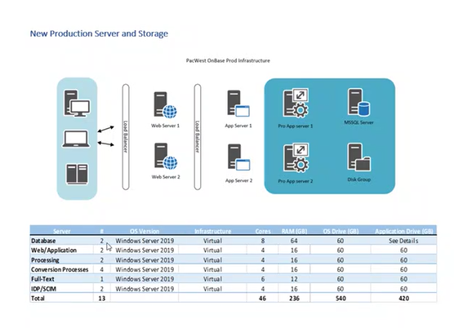

**Hyland OnBase is designed as a THREE-TIER architecture**, separating the **Client, Application, and Database Layers** for **scalability, security, and high performance.**

**Application & Deployment:**

* The primary Operating system is Windows Server 2019.
* The primary database is Microsoft SQL Server 2019.
* The Primary Disk Group is Local Disks (NTFS, SAN, NAS).
* Application is deployed on IIS (Internet Information Services).
* Hyland provides an official OnBase Installer (.exe or .msi) as part of their software package that supports Windows Server environments for hosting OnBase.
* Includes:
  + OnBase Server Installer
  + OnBase Database Configuration Installer
  + OnBase Client Installer
  + OnBase API Services Installer
  + OnBase Studio (Workflow Designer)
* Secrets and configurations are stored in configuration files, registry settings, and the SQL database. These configurations define server settings, database connections, security policies, and storage locations for the OnBase system.
* Deployments are handled via:
  + Running OnBaseSetup.exe on the OnBase Application Windows Server
  + Configuring SQL Server Connection (OnBase needs access to a database)
  + Install OnBase Web Services (IIS-based application),
  + Run OnBase Client Installer on end-user machines.

**Infrastructure & Configuration:**

* No Infrastructure as Code (IaC) or Configuration as Code (CaC) is in place.
* Upgrading (Minor and Major Patches) Hyland OnBase On-Premises involves manual update of the application server, database, web components, and clients while ensuring minimal downtime and data integrity.
* Hyland releases OnBase upgrades periodically, including security patches, feature enhancements, and bug fixes and require proper planning to avoid disruption in document workflows and integrations.

**Application Characteristics:**

* Hyland OnBase is a stateful application, retaining user session data, workflow history, and document indexing and OnBase relies on a database (SQL Server ) and disk groups to persist document data and user session management is handled at the application level (via IIS for web access) and database level for transactions.

**Technology Stack:**

* The Backend: .NET Framework, SQL Server for database storage
* Frontend: Web Client (HTML5, JavaScript), Unity Client (Windows).
* Storage: NTFS, NAS, SAN.
* Integrations: REST/SOAP APIs.

**Security Operations:**

OnBase Security Audit Process helps organizations track user activities, document access, workflow changes, and system events to ensure compliance, security, and data integrity.

* Logs user access, document changes, workflow actions, and system events.
* Detects unauthorized access, failed login attempts, and policy violations.
* Meets compliance requirements like HIPAA, GDPR, SOX, ISO 27001.
* Supports forensic investigations by providing detailed audit logs.

**Monitoring & Orchestration:**

* Application monitoring is handled OnBase Native monitoring using OnBase System Diagnostics Report that provides an overview of system performance, workflow execution, errors, and storage health..

**Data Growth & Retention: 1 TB, 8 years(?)**

## Findings and Risks

Microsoft SQL Server 2019 enters the Extended Support phase in February 2025. It will no longer receive bug fixes or feature improvements, only security updates if an Extended Security Update (ESU) plan is purchased.

Target Arch

**Configuration Management Risks:**

* IIS configurations should be versioned to enable rollback, tracking changes, and disaster recovery. IIS does not have built-in version control, but you can automate versioning using backups, Git, PowerShell DSC, and configuration management tools like Ansible or Terraform nor properly maintained, posing security and operational risks.
* SQL Server configurations can be versioned to track database schema, server settings, stored procedures, indexes, and user permissions. While SQL Server does not have built-in version control, you can achieve versioning using SQL scripts, Git, automated backups or Azure DevOps.

**CI/CD Weaknesses:**

* OnBase On-Premises is a stateful, monolithic application with tight database dependencies, making CI/CD difficult. Unlike cloud-native applications, OnBase relies on manual deployments, complex database structures, and Windows-based infrastructure, which slows down automation.

**Scalability and Reliability Concerns:**

* Scalability issues arise from database constraints, application load balancing, and storage limitations.
* Reliability concerns stem from single points of failure, lack of automated failover and manual recovery processes.

**Data Growth & Performance Impact:**

## Recommendations

**Target Architecture:**

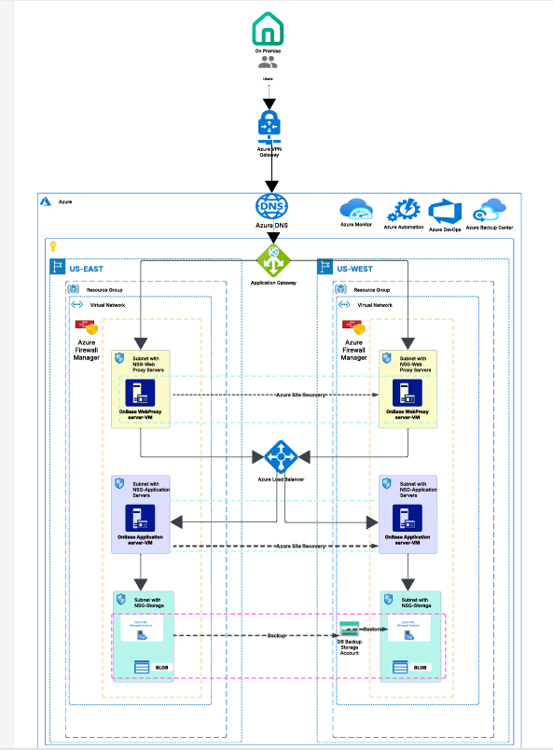

**Azure Deployment:**

Hyland OnBase from on-premises to Azure Cloud provides scalability, high availability, security, and cost optimization. Azure’s global infrastructure enables better disaster recovery, storage efficiency, and automated management, making it an ideal cloud platform for OnBase.

* Eliminates On-prem hardware costs with Azure’s pay-as-you-go model.
* Enhances disaster recovery (DR) and business continuity with multi-region/AZ replication.
* Improves performance & scalability with Azure SQL Managed Instance & Blob Storage.
* Automates deployments & security updates using Azure DevOps & Security Center.

**Database Modernization:**

* The self-managed Microsoft SQL Server should be migrated to a managed SQL Server instance, ensuring better availability, automated maintenance, and security compliance.
* Regular backups should align with Recovery Point Objectives (RPO) to prevent data loss.

**Disk Groups Migration:**

Migrating Hyland OnBase Disk Groups from on-prem NAS/SAN to Azure Blob Storage provides scalability, cost efficiency, high availability, and automated backups. Azure Blob Storage eliminates storage limitations, improves document retrieval speeds, and reduces storage management complexity

* Scales infinitely without hardware limitations.
* Lower costs with Azure Storage Tiers (Hot, Cool, Archive).
* Automatic replication, backup, and disaster recovery (DR).
* Improves security with encryption, access control, and monitoring.
* Optimized performance with geo-redundant storage (GRS).

**Hyland**

**Azure Infrastructure Components:**

* **Resource Groups**: Container for managing Azure resources (shown in both US-East and US-West)
* **Virtual Networks**: Isolated network environments in Azure (one per region)
* **Subnets with NSGs (Network Security Groups)**:
  + Storage subnet
  + Web Proxy subnet
  + Application Servers subnet
* **Azure Firewall Manager**: Provides centralized security policy management
* **Azure Load Balancer**: Distributes incoming traffic across regions
* **Application Gateway**: Manages web traffic to applications
* **Azure DNS**: Domain name resolution service
* **Azure VPN Gateway**: Connects on-premises network to Azure
* **Storage Account**: For DB backup storage
* **BLOB Storage**: For unstructured data storage

**OnBase Application Components:**

* **OnBase WebProxy server-VMs**: Front-end servers handling client requests
* **OnBase Application server-VMs**: Back-end servers running the OnBase application logic

**Management and Monitoring Services:**

* **Azure Monitor**: For performance monitoring and alerting
* **Azure Automation**: For task automation and configuration management
* **Azure Backup Center**: Centralized backup management
* **Azure Site Recovery**: Disaster recovery service
* **Azure DevOps**: For CI/CD and application lifecycle management

**Architecture Overview:** This diagram shows a high-availability deployment of OnBase (a content services platform) across two Azure regions (US-East and US-West). The architecture implements:

1. **Redundancy**: Duplicate infrastructure in both regions for high availability
2. **Security**: Network segmentation with subnets and NSGs
3. **Connectivity**: VPN connection to on-premises environment
4. **Disaster Recovery**: Azure Site Recovery for business continuity
5. **Backup**: Database backups stored in Azure Storage

The flow appears to show user traffic coming in through the load balancer, being directed to the appropriate region, passing through application gateway to the web proxy servers, which then communicate with the application servers. The application servers interact with storage for persistent data

# Infrastructure

Refer to the Annexure Section for the list of servers / virtual servers in the infrastructure.

## Findings and Risks

**Infrastructure Overview:**

* The infrastructure spans across CTC and ELR datacenters, ensuring resiliency and high availability.
* It includes set of Windows and servers (Windows Server 2019, IIS (Internet Information Services). Microsoft SQL Server 2019, Local Disks (NTFS, SAN, NAS) that host web applications, application services, Disk Groups, and databases.

**Application:** Hyland OnBase is a **Enterprise Content Management (ECM) system.**

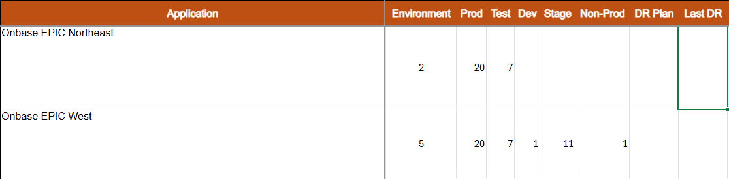

**Server Management:(TBD)**

**Monitoring & Logging:(TBD)**

**Load Balancing:**

Each application endpoint is managed by a dedicated F5 load balancer instance, ensuring efficient traffic distribution and high availability. After migration Azure Application Load balancer will be used instead of F5.

**CI/CD Infrastructure:(TBD)**

## Recommendations

**Environment Segregation:**

* It is recommended to establish dedicated VNets for production and non-production environments to enhance security and isolation.

**Infrastructure Monitoring:**

* The infrastructure should be monitored using Azure-native monitoring tools or a solution recommended by ARB (Architecture Review Board) for better visibility and compliance.

**Traffic Management & Security:**

* It is recommended to integrate Azure Load Balancer, Azure Front Door, and Web Application Firewall (WAF) to improve traffic distribution, security, and global reachability.

# Security and Compliance(TBD)

The security and compliance portion evaluation.

## Findings and Risks

## Recommendations

* Network level and application-level penetration testing should be performed periodically.
* Runtime vulnerability scanning must be implemented to detect zero-day vulnerabilities and enhance overall security posture.

# Data Management(TBD)

## Data classification and tagging

OnBase West Team - LOB Optum SQL Server - [LOBOptumSQLServer_DL@ds.uhc.com](mailto:LOBOptumSQLServer_DL@ds.uhc.com)

OnBase East Team - ORX IT SQL Server DBA - [dl-mssqldba7696@uhgazure.onmicrosoft.com](mailto:dl-mssqldba7696@uhgazure.onmicrosoft.com)

OnBase Data Bases:

|  |  |  |  |  |  |  |  |  |  |
| --- | --- | --- | --- | --- | --- | --- | --- | --- | --- |
| **OnBase East Test** |  |  |  |  |  |  |  |  |  |
| UHGWM110-028894 | azb | wn000041821 | 4 | mn011 | 10.29.197.177 | 16 | CORE | TEST | DB SQL Standalone |
| **OnBase East Prod** |  |  |  |  |  |  |  |  |  |
| ['wp000041858', 'wp000041857', 'wp000041856'] | azb |  | 8 | mn053 | ['10.28.204.119', '10.28.86.16', '10.29.85.227'] | 64 | CORE | PROD | DB MS SQL Cluster |
|  |  |  |  |  |  |  |  |  |  |
| **OnBase West Prod** |  |  |  |  |  |  |  |  |  |
| AO Cluster name | ELR | AZA | 8 | 64 |  | wp000082609cls |  | PROD | DB SIZE - 1024 GB |
| Primary Node | ELR | AZA | 8 | 64 |  | WP000082609 | 10.87.24.65 | PROD |  |
| Secondary Node | ELR | AZB | 8 | 64 |  | WP000082608 | 10.106.174.66 | PROD |  |
| DR Node | CTC | AZB | 8 | 64 |  | WP000082610 | 10.86.144.103 | PROD |  |
|  |  |  |  |  |  |  |  |  |  |
| **OnBase West Test** |  |  |  |  |  |  |  |  |  |
| **Server Role** | **Zone** | **cpu** | **memory** | **space (GB)** | **Server Name** |  | **IP** |  |  |
| DB SQL Standalone | AZA | 4 | 16 | 1000 | wn000078777 | Test | 10.86.36.46 |  |  |
| **OnBase West Stage** |  |  |  |  |  |  |  |  |  |
| **Server Role** | **DC** | **Zone** | **cpu** | **space (GB)** | **RAM** | **Server Name** | **IP** |  |  |
| AO Cluster name | ELR | AZA | 8 |  | 64 | wn000081899cls |  | DB SIZE - 1024 GB |  |
| Primary Node | ELR | AZA | 8 |  | 64 | WN000081899 | 10.87.182.72 |  |  |
| Secondary Node | ELR | AZB | 8 |  | 64 | WN000081900 | 10.28.202.209 |  |  |

## Findings and Risks

**Data Management Gaps: Hyland OnBase software must be installed on VMs**

**Data Growth & Volume: 1 TB in West and East**

## Recommendations

**Establish Data Backup Policies:**

* Define data backup policies aligned with business continuity planning (BCP) to ensure data availability, recovery, and resilience against failures.

**Implement Data Retention Policies:**

* Define data retention policies to purge or archive old data, reducing storage growth and improving system performance.
* Proper data retention will also help minimize legal liabilities associated with PII, ensuring compliance with regulatory requirements.

# TCO Assessment & Management(TBD)

## Findings and Risks

**Infrastructure Utilization:**

East: $17,693.75 per month; $212,325.03 per year

West: $34,177.93 per month; $410,135.19 per year

**Server Decommissioning:** refer infrastructure sheet

**Database Support Lifecycle:**

* Microsoft SQL Server 2019 has reached the end of mainstream support and has entered the extended support phase.
* This transition may lead to additional support costs or necessitate an upgrade to a supported version to ensure continued security and compliance.

## Recommendations

**Application Modernization:**

* Rehosting the application on Azure Cloud infrastructure.
* This approach enables better scalability, orchestration, and resource efficiency.

**Database Migration:**

* Migrate Microsoft SQL Server to the cloud, leveraging managed services for automated backups, maintenance, and high availability, reducing manual configuration and operational overhead.

**Adoption of Azure Native Services:**

* Transition to Azure-native solutions such as Azure Load Balancer, API Gateway, Front Door, WAF, Monitoring, and Logging.
* This enhances performance, security, and observability, while reducing reliance on manually managed infrastructure.

# Business Continuity & Disaster Recovery**(TBD)**

Business Continuity (BC) and Disaster Recovery (DR) in private cloud environments are focused on ensuring minimal downtime and maintaining continuous operations through robust infrastructure design, including redundant systems and data replication across multiple locations. These strategies involve detailed planning and testing to handle potential disruptions smoothly, including automated failover to backup systems and regular recovery drills to ensure all systems and processes are effective and ready to deploy in an emergency. By leveraging the inherent scalability and control of private clouds, organizations can tailor their BC/DR plans to meet specific needs, ensuring both swift recovery from incidents and resilience in ongoing operations.

|  |  |  |
| --- | --- | --- |
| **Aspect** | **Business Continuity (BC)** | **Disaster Recovery (DR)** |
| **Primary Goal** | Ensure that business operations continue without significant disruption. | Restore critical IT functions and data access quickly after a disruption. |
| **Focus Area** | Holistic approach that includes all aspects of the organization’s operations. | Specifically focuses on IT and data systems recovery. |
| **Implementation** | Requires strategies that cover the entire organization, often involving multiple sites. | Typically involves technical solutions such as data backup and failover systems. |

## Findings and Risks**(TBD)**

## Recommendations

* Implement Azure Site recovery upon Re-hosting the application suite using Azure native services.

# Annexure 1: Server List

| **Application** | **ITSM Environment** | **ITSM FQDN** | **ITSM Operating System** | **Server Details** | **CPU Count** | **Mem** | **Location** |
| --- | --- | --- | --- | --- | --- | --- | --- |
| OnBase | Production | wp000041848.ms.ds.uhc.com | Microsoft windows 2019 |  | 4 | 16 | ELR |
| OnBase | Production | wp000041849.ms.ds.uhc.com | Microsoft windows 2019 |  | 4 | 16 | ELR |
| OnBase | Production | wp000041850.ms.ds.uhc.com | Microsoft windows 2019 |  | 4 | 16 | ELR |
| OnBase | Production | wp000041851.ms.ds.uhc.com | Microsoft windows 2019 |  | 4 | 16 | ELR |
| OnBase | Production | wp000041852.ms.ds.uhc.com | Microsoft windows 2019 |  | 4 | 16 | ELR |
| OnBase | Production | wp000041853.ms.ds.uhc.com | Microsoft windows 2019 |  | 4 | 16 | ELR |
| OnBase | Production | wp000041854.ms.ds.uhc.com | Microsoft windows 2019 |  | 6 | 12 | ELR |
| OnBase | Production | wp000041855.ms.ds.uhc.com | Microsoft windows 2019 |  | 6 | 12 | ELR |
| OnBase | Production | wp000041856.ms.ds.uhc.com | Microsoft windows 2019 |  | 8 | 64 | CTC |
| OnBase | Production | wp000041857.ms.ds.uhc.com | Microsoft windows 2019 |  | 8 | 64 | ELR |
| OnBase | Production | wp000041858.ms.ds.uhc.com | Microsoft windows 2019 |  | 8 | 64 | ELR |
| OnBase | Production | wp000041858cls.ms.ds.uhc.com | Microsoft windows 2019 |  | 8 | 64 | ELR |
| OnBase | Production | wp000041867.ms.ds.uhc.com | Microsoft windows 2019 |  | 4 | 16 | CTC |
| OnBase | Production | wp000041868.ms.ds.uhc.com | Microsoft windows 2019 |  | 6 | 12 | CTC |
| OnBase | Production | wp000041869.ms.ds.uhc.com | Microsoft windows 2019 |  | 6 | 12 | CTC |
| OnBase | Production | wp000041870.ms.ds.uhc.com | Microsoft windows 2019 |  | 4 | 16 | CTC |
| OnBase | Production | wp000041871.ms.ds.uhc.com | Microsoft windows 2019 |  | 4 | 16 | CTC |
| OnBase | Production | wp000041872.ms.ds.uhc.com | Microsoft windows 2019 |  | 4 | 16 | CTC |
| OnBase | Production | wp000041873.ms.ds.uhc.com | Microsoft windows 2019 |  | 4 | 16 | CTC |
| OnBase | Production | wp000041874.ms.ds.uhc.com | Microsoft windows 2019 |  | 4 | 16 | CTC |

Database Teams

OnBase West Team - LOB Optum SQL Server - [LOBOptumSQLServer_DL@ds.uhc.com](mailto:LOBOptumSQLServer_DL@ds.uhc.com)

OnBase East Team - ORX IT SQL Server DBA - [dl-mssqldba7696@uhgazure.onmicrosoft.com](mailto:dl-mssqldba7696@uhgazure.onmicrosoft.com)

OnBase Data Bases:

|  |  |  |  |  |  |  |  |  |  |
| --- | --- | --- | --- | --- | --- | --- | --- | --- | --- |
| **OnBase East Test** |  |  |  |  |  |  |  |  |  |
| UHGWM110-028894 | azb | wn000041821 | 4 | mn011 | 10.29.197.177 | 16 | CORE | TEST | DB SQL Standalone |
| **OnBase East Prod** |  |  |  |  |  |  |  |  |  |
| ['wp000041858', 'wp000041857', 'wp000041856'] | azb |  | 8 | mn053 | ['10.28.204.119', '10.28.86.16', '10.29.85.227'] | 64 | CORE | PROD | DB MS SQL Cluster |
|  |  |  |  |  |  |  |  |  |  |
| **OnBase West Prod** |  |  |  |  |  |  |  |  |  |
| AO Cluster name | ELR | AZA | 8 | 64 |  | wp000082609cls |  | PROD | DB SIZE - 1024 GB |
| Primary Node | ELR | AZA | 8 | 64 |  | WP000082609 | 10.87.24.65 | PROD |  |
| Secondary Node | ELR | AZB | 8 | 64 |  | WP000082608 | 10.106.174.66 | PROD |  |
| DR Node | CTC | AZB | 8 | 64 |  | WP000082610 | 10.86.144.103 | PROD |  |
|  |  |  |  |  |  |  |  |  |  |
| **OnBase West Test** |  |  |  |  |  |  |  |  |  |
| **Server Role** | **Zone** | **cpu** | **memory** | **space (GB)** | **Server Name** |  | **IP** |  |  |
| DB SQL Standalone | AZA | 4 | 16 | 1000 | wn000078777 | Test | 10.86.36.46 |  |  |
| **OnBase West Stage** |  |  |  |  |  |  |  |  |  |
| **Server Role** | **DC** | **Zone** | **cpu** | **space (GB)** | **RAM** | **Server Name** | **IP** |  |  |
| AO Cluster name | ELR | AZA | 8 |  | 64 | wn000081899cls |  | DB SIZE - 1024 GB |  |
| Primary Node | ELR | AZA | 8 |  | 64 | WN000081899 | 10.87.182.72 |  |  |
| Secondary Node | ELR | AZB | 8 |  | 64 | WN000081900 | 10.28.202.209 |  |  |